METAS Calibration Workshop for   
particle analyzers in calendar week 8

The realisation of the workshop requires a minimum of 3 participating instruments, and is limited to a total of 6 instruments. Devices with a high volumetric sample flow rate (> 5 L/min, e.g. EEPS) and devices exceeding the maximum allowable number will be transferred to **a second workshop.** Concerned participants will be contactedindividually.

**The deadline for registration is calendar week 3.**

# Goal

The workshop enables the participants to calibrate their particle measuring systems with real combustion aerosol in a controlled environment. The instruments shall be operated at the settings the participants normally use. Thus, the results and the evaluated deviations from the reference values indicate the reliability of the measurements (particle number concentration and mobility diameter[1]) at the individual measuring conditions. The exchange of results and experience among the participants will permit to optimize the individual measuring procedure.

# METAS particle laboratory

## Infrastructure

The workshop will take place in the particle laboratory of METAS. Air conditioning maintains a room temperature of 21 °C ± 1 °C.

For the installation of the measuring instrument a table space of about 0.5 m2 is provided. Each space is equipped with a power supply (230 V socket according to Swiss standard) and particle-free and dry compressed air (6 bar, 6 mm steel tubing). Nitrogen (Quality 50, < 6 bar) is available on request.

Additional installations can be prepared on request in advance.

## Experimental setup for operation

A maximum of 6 instruments will be arranged according to Figure 1. The combustion aerosol from the CAST (Combustion aerosol Standard) is multi-stage diluted, thermally treated to remove volatile compounds, neutralized with a Krypton-source, split and distributed to the various instruments using tubes of 8 mm ∅ (Figure 2). Tube lengths are adapted according to sampling flow rates. The splitter is kept at atmospheric pressure using an exhaust outlet, and the instruments draw the required volume flow (up to 5 L/min).

|  |  |
| --- | --- |
| Instruments  **Table 1**  Instruments  Instruments  **Table 2**  Instruments  Instruments  **Hood**  bigCAST METAS |  |
| Figure 1 Arrangement of the instruments | Figure 2 Schematic illustration of the particle generation unit |

# Measurement procedure

## Schedule

* Preparations (Tuesday, morning):  
  Arrival, installation, briefing and test run with combustion aerosol, if needed
* First day of operation (Tuesday afternoon):  
  Run with particles approx. 80 nm[2]); 3 concentrations[3])  
  Run with particles approx. 120 nm; 3 concentrations
* Second day of operation (Wednesday):   
  Run with particles approx. 40 nm; 3 concentrations   
  Run with particles approx. 180 nm; 3 concentrations   
  Debriefing, unrigging, departure
* Thursday morning if needed
* No later than one month after the comparison:  
  Participant must hand the measured data to METAS according to previously specified formats and layout.
* No later than three months after the comparison:   
  Distribution of the results overview and the certificate to each participant

## Transport and installation of the instruments

Participants are responsible for the transportation of their own instrument(s) to METAS. Because Switzerland is not a member of EU, specific administrative procedures for instruments, e.g. customs, need to be considered (<https://www.metas.ch/metas/en/home/dl/geraete-ans-metas-senden.html>).

As the transportation of radioactive neutralizers is strictly regulated, we recommend to ship neutralisers separately with an authorized carrier. Upon request, METAS can provide a limited number of own neutralizers.

At the day of arrival at METAS, participants must install and test their instrument(s), execute all the necessary calibrations and adjustments as they normally do in their own lab. To this end, test combustion aerosols can be provided by METAS upon request.

## Measurement procedure

The comparison measurements are performed in four half-day sections, each covering one particle diameter (see Figure 3). The aerosol is kept stable during a time period of 30 minutes (run). For each run the average key parameter for the aerosol[4] shall be evaluated.

Every participant should operate her/his instrument according to her/his own quality manual.

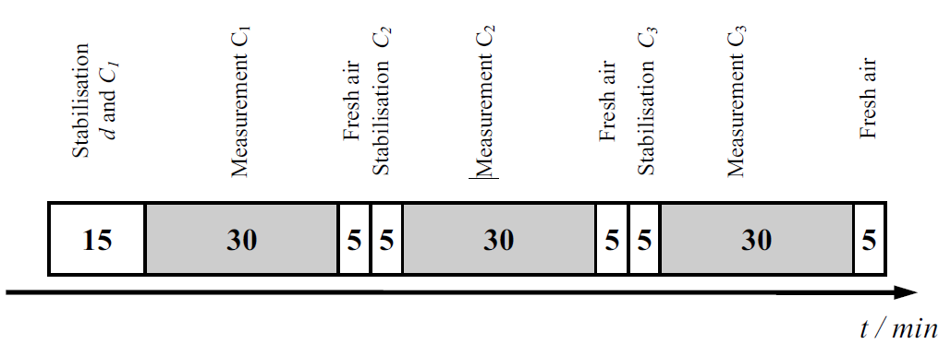

Figure 3 Procedure scheme for the measurements at each particle size with three different particle number concentrations (C1<C2<C3)

## Key parameters of the aerosol

Every participant will evaluate his (her) ensemble of results for each run and forward these to METAS in order to compile an overview of the results. For this purpose, METAS will provide a standardised spreadsheet (EXCEL) with the following sections:

* Identification and settings of instrument
* Average particle sizes *dg* (geometric mean of the size distribution)
* Geometric standard deviation *σg* (GSD)
* Particle number concentration [cm-3] (integral of the size distributions)
* Standard deviations and number of measured values (for geometric mean, GSD, particle number concentrations)

## Final report and certificate

In contrast to earlier campaigns, METAS will not issue a final report with a detailed presentation of the verified data of all participants. The final report will be replaced by a short result overview (anonymised) and an individual calibration certificate for each participant. The rights for publishing the anonymised data and results will remain at METAS.

# Trip and accommodation

Site plan for METAS see: <https://www.metas.ch/metas/en/home/metas/standort.html>

Hotels see: <https://www.bern.com/en/where-to-stay>

# Costs

* Participants must cover their own expenses and arrange the transportation/shipping of their instrument(s) to METAS.
* Participation fee for each instrument: CHF 1500.00
* If a participant cannot attend the workshop and operate his (her) instrument on his (her) own, METAS can take over. The instrument will be operated according to the instructions of the participant. The raw data will be sent to the participant for data evaluation.

Additional cost if the instrument is operated by METAS during the workshop: CHF 540.00

All prices excl. VAT

Registration for the Calibration Workshop for particle analyzers for calendar week 8

|  |  |
| --- | --- |
| Send to: | Federal Institute of Metrology METAS Stefan Horender Lindenweg 50, 3003 Bern-Wabern  Tel. +41 58 387 03 72 Fax +41 58 387 02 10  Email: [stefan.horender@metas.ch](mailto:stefan.horender@metas.ch)  Email: [Christian.waelchli@metas.ch](mailto:Christian.waelchli@metas.ch) |

# Contact

|  |  |
| --- | --- |
| Company: |  |
| Name: |  |
| Address: |  |
| PC, City, Country: |  |
| Telephone: |  |
| Email: |  |

|  |
| --- |
| Instrument* * please use one form per measuring system  Manufacturer:  Instrument components:  Type/Model:       Serial number:        Type/Model:       Serial number:        Type/Model:       Serial number:        Flow rate:       L/min Inlet aperture:       mm external ∅  Option: Instrument operation by METAS Yes  No |
| Extent of the comparison:  Combustion Aerosol from CAST (Combustion Aerosol STandard)  Nominal values of 3 concentrations: 103 cm-3 to 5x105 cm-3  Nominal values of 3 particle diameters: 40 nm, 80 nm, 120 nm and 180 nm  Exchange of experiences  In principle, all instruments are operated by the customers during the campaign. Therefore it is necessary that the customer attend the whole measurement procedure. |

Place, Date, Signature:

Please send this document per mail or electronically to the above address.  
**Registration deadline: CW 3.** A minimum number of 3 participants is required for the workshop.

*The “METAS General Terms and Conditions” apply to all services of METAS. They are available at* www.metas.ch*. Amendments, subsidiary agreements and supplements shall always have to be made in writing.*

1. ) Mobility diameter according ISO 15900
2. ) Particle diameter as mode of a size distribution with a geometric standard deviation (GSD) ~1.6
3. ) Concentrations in a range of 103 Particles/cm3 to 5x105 Particles/cm3.
4. Jürg Schlatter (2009) Measurement of Particles in Aerosols – Challenge and Solutions, CHIMIA, 63/10, p 665-669